Test Case: tc003_SPX_Dev5_Crear_Requisicion_Spot_Tipo_Cobro_CC_Urgent
Step 1 - Enter username and password and click to button Enter : Credentials Entered
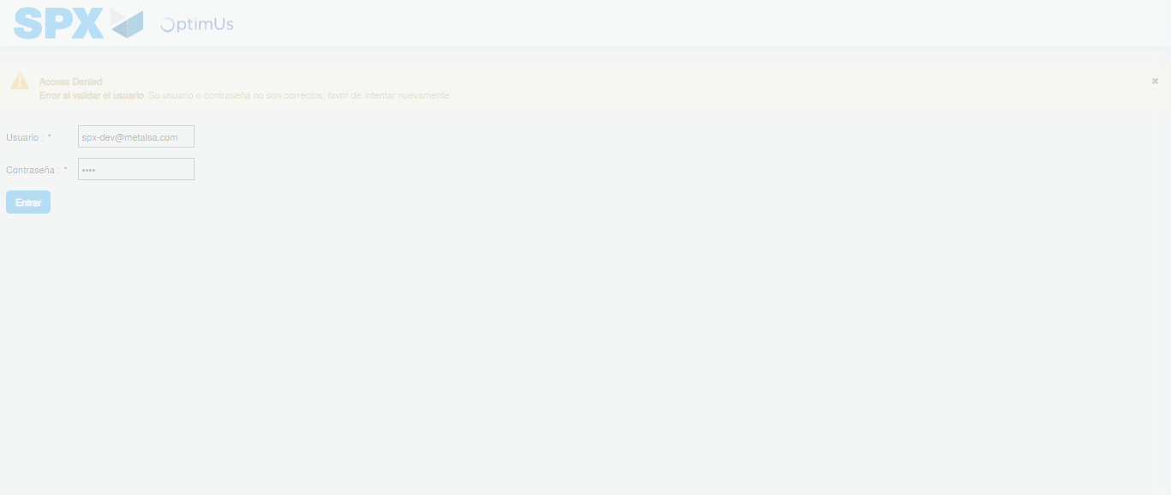Image file-name: QC_Testing-tc003_SPX_Dev5_Crear_Requisicion_Spot_Tipo_Cobro_CC_Urgent-1782315320952

Step 2 - Select to UEN and Access to Spot Buy Requisitions : UEN Correctly selected and Correct access
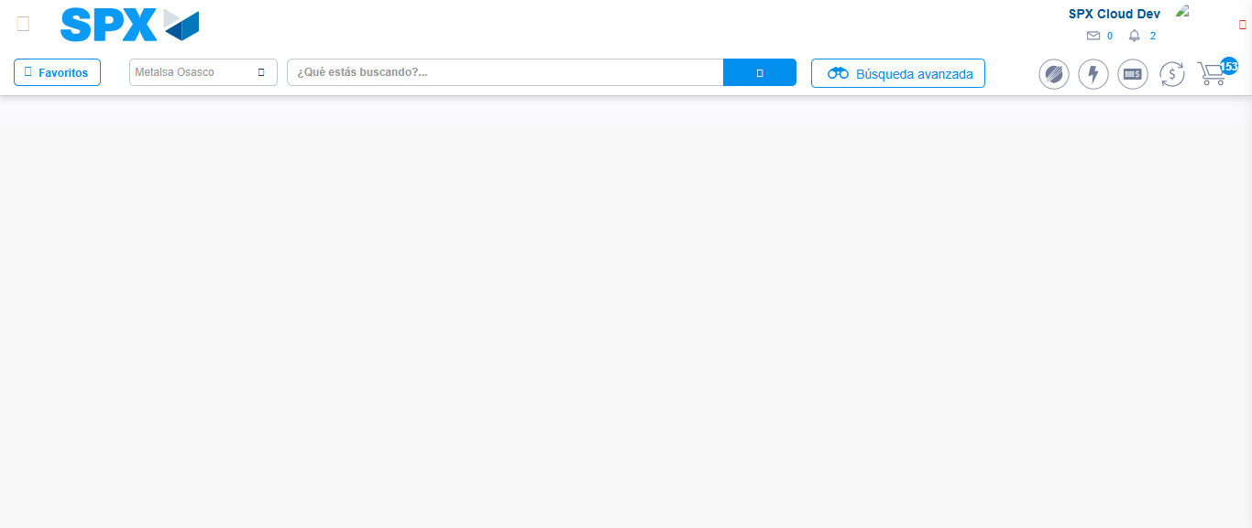Image file-name: QC_Testing-tc003_SPX_Dev5_Crear_Requisicion_Spot_Tipo_Cobro_CC_Urgent-1782315352062

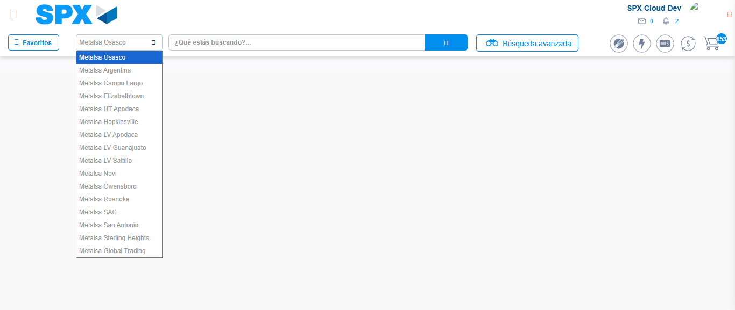Image file-name: QC_Testing-tc003_SPX_Dev5_Crear_Requisicion_Spot_Tipo_Cobro_CC_Urgent-1782315354653

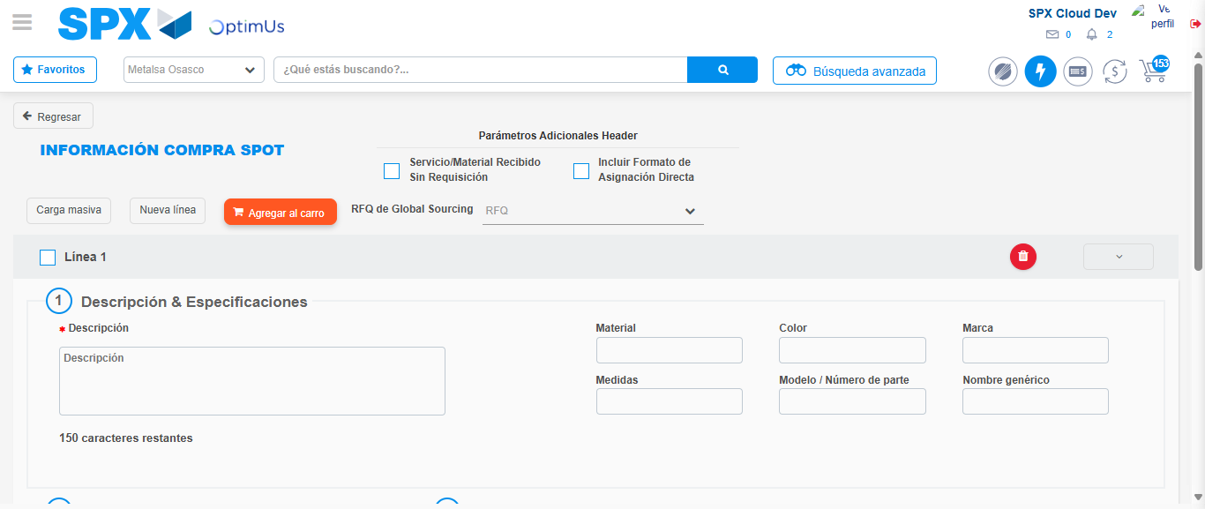Image file-name: QC_Testing-tc003_SPX_Dev5_Crear_Requisicion_Spot_Tipo_Cobro_CC_Urgent-1782315369389

Step 3 - Data Capture Spot Buy Requisition: Data captured correctly
Image file-name: QC_Testing-tc003_SPX_Dev5_Crear_Requisicion_Spot_Tipo_Cobro_CC_Urgent-1782315369693

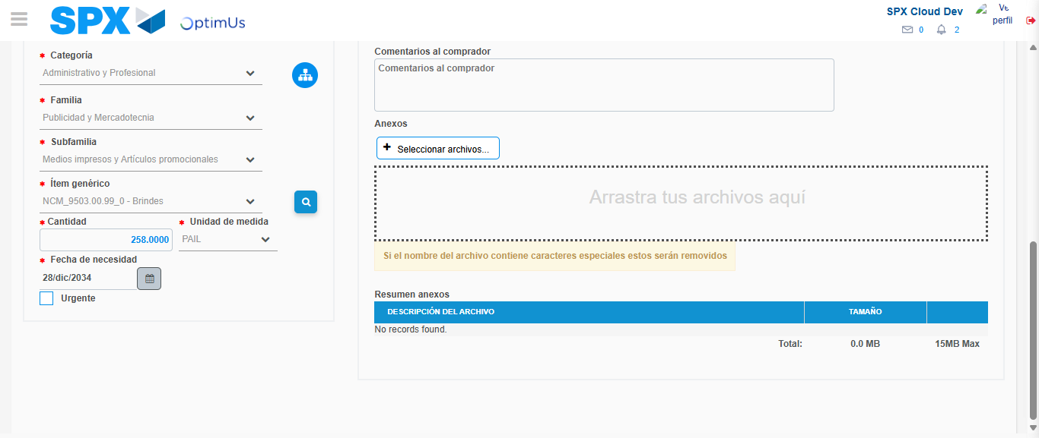Image file-name: QC_Testing-tc003_SPX_Dev5_Crear_Requisicion_Spot_Tipo_Cobro_CC_Urgent-1782315384516

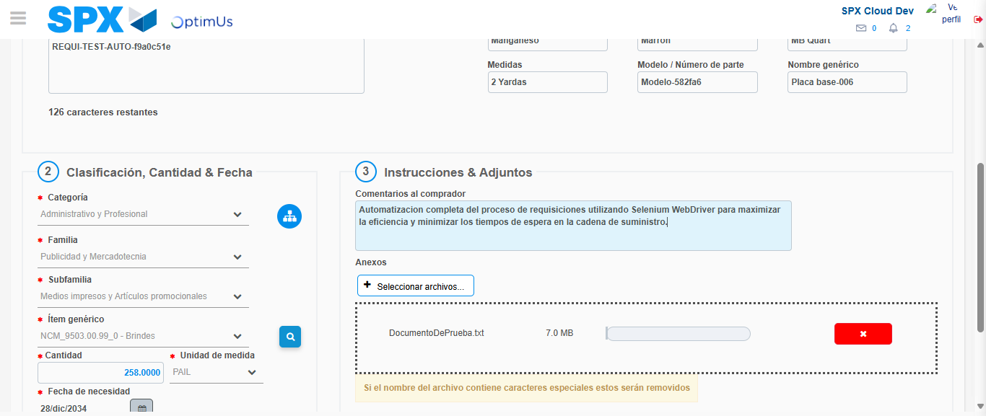Image file-name: QC_Testing-tc003_SPX_Dev5_Crear_Requisicion_Spot_Tipo_Cobro_CC_Urgent-1782315385388

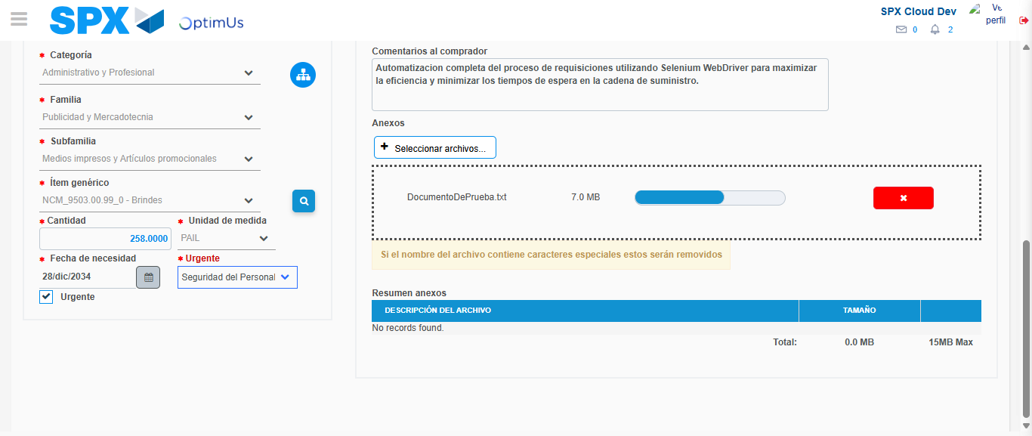Image file-name: QC_Testing-tc003_SPX_Dev5_Crear_Requisicion_Spot_Tipo_Cobro_CC_Urgent-1782315389351

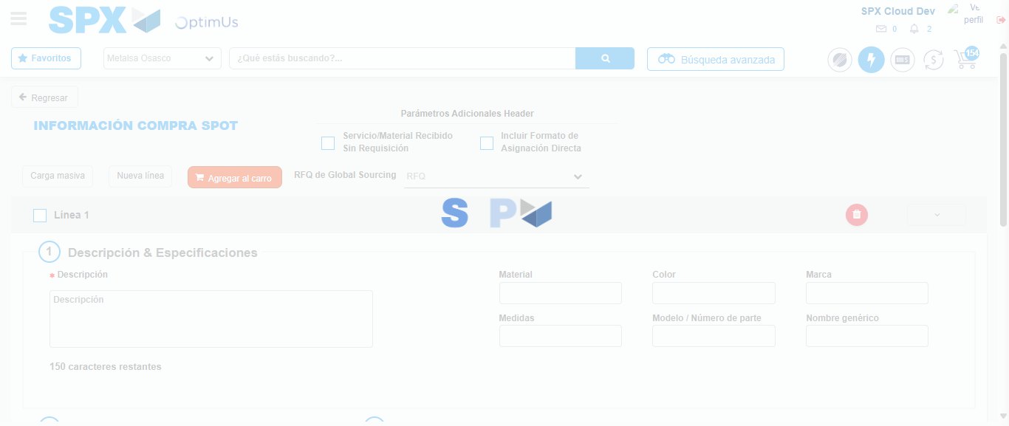Image file-name: QC_Testing-tc003_SPX_Dev5_Crear_Requisicion_Spot_Tipo_Cobro_CC_Urgent-1782315404295

Step 7 - Return to Main Page SPX : Return to Main Page SPX
Image file-name: QC_Testing-tc003_SPX_Dev5_Crear_Requisicion_Spot_Tipo_Cobro_CC_Urgent-1782315352062

Image file-name: QC_Testing-tc003_SPX_Dev5_Crear_Requisicion_Spot_Tipo_Cobro_CC_Urgent-1782315354653

Image file-name: QC_Testing-tc003_SPX_Dev5_Crear_Requisicion_Spot_Tipo_Cobro_CC_Urgent-1782315369389

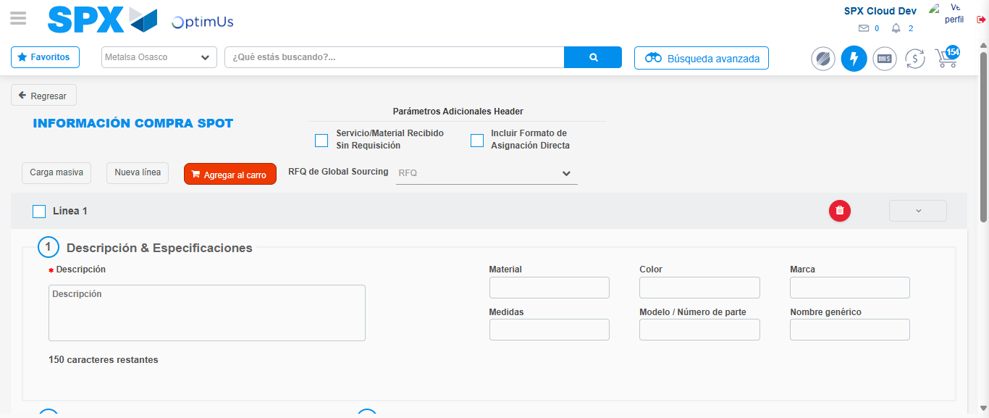Image file-name: QC_Testing-tc003_SPX_Dev5_Crear_Requisicion_Spot_Tipo_Cobro_CC_Urgent-1782315406575

Image file-name: QC_Testing-tc003_SPX_Dev5_Crear_Requisicion_Spot_Tipo_Cobro_CC_Urgent-1782315406819

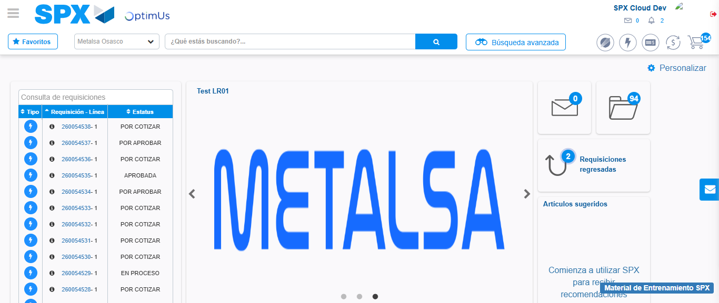Image file-name: QC_Testing-tc003_SPX_Dev5_Crear_Requisicion_Spot_Tipo_Cobro_CC_Urgent-1782315428150

Step 8 - Log Out : Log Out SPX
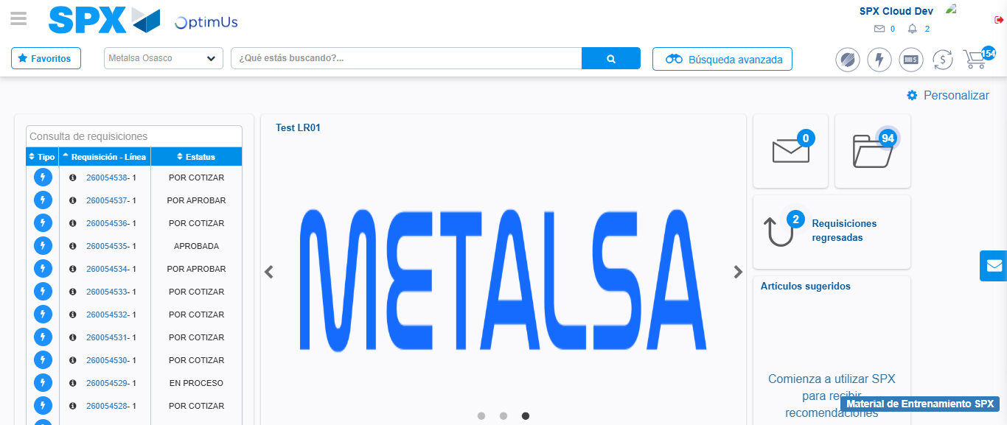Image file-name: QC_Testing-tc003_SPX_Dev5_Crear_Requisicion_Spot_Tipo_Cobro_CC_Urgent-1782315428499

